My friend LULU
My friend is nice. She is not scared of dogs and cats. She is scared of mice and the dark. She is 9 years old. She has got a guinea pig. Guinea pig is white and brown. Guinea pig's name is Emma. Guinea pig is 1 year old. Lulu has got a nice pink ruler, blue rubber, green and orange pen and grey book. She likes vegetables. She likes school. Lulu likes Emma.
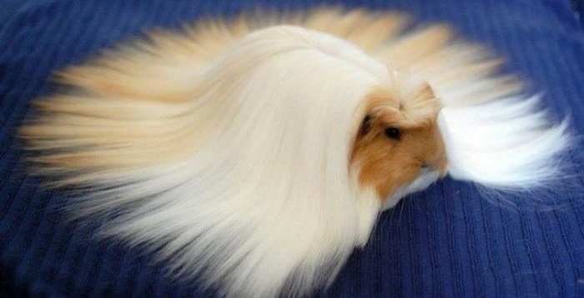
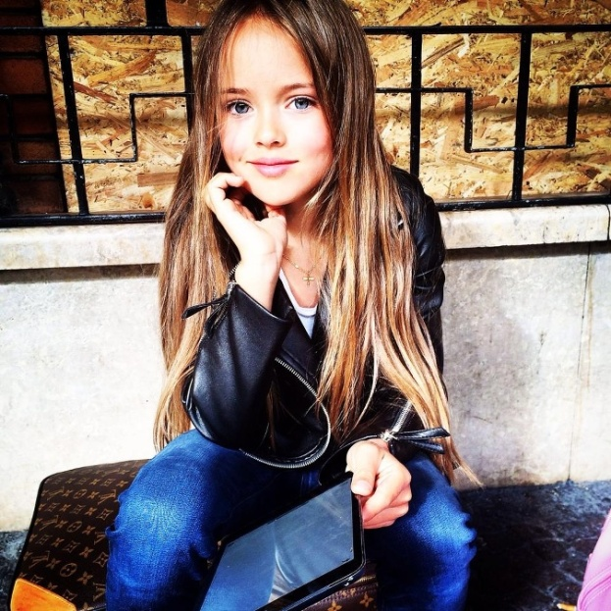

Monika Galuščáková, 3.C

